**‘ WMWI**

**The National Federation of WI’s campaign to**

**I improve women’s and family’s lives**



**Monthly Newsletter: March 2024: No 201**

[**www.waltonmanorwi.co.uk**](http://www.waltonmanorwi.co.uk)

**President:** Caroline Coleman - 07850 830858

**Secretary:** Clare Wildish - 01865 556018 **Walton Manor WI Treasurer & Vice President:**  Liz Jennings - 07717 756338 **Registered charity 1119651**

**NEXT MEETING WMWI**

**WHEN Tuesday 12th March**

**WHERE St Margaret’s Institute**

**Polstead Road**

**TIME 7.30pm for 8pm start**

**SPEAKER A representative from St Mungo’s will be explaining about the homeless charity.**

**Also it is our Annual Meeting**

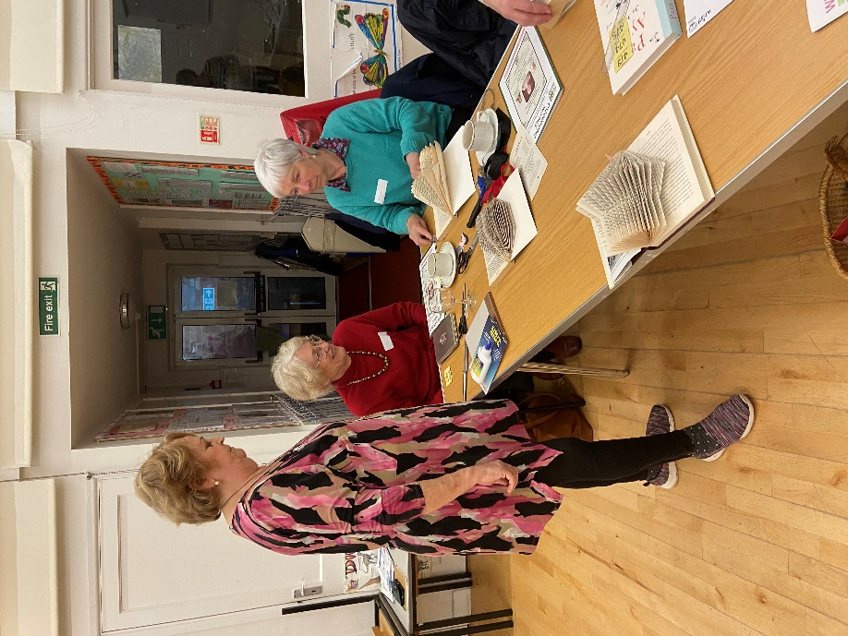**LAST MONTH’S MEETING**

Our speaker was Mrs Graeme Gettings. She is Chair of Home & Garden at OFWI.

This was a practical workshop and was great fun. Graeme demonstrated how to make a paper hedgehog and a fairy house. We had brought along all the equipment needed.

Members set about folding their books and we were all very industrious. The finished results were truly delightful.

After the hedgehog Graeme then went on to demonstrate a paper fairy house

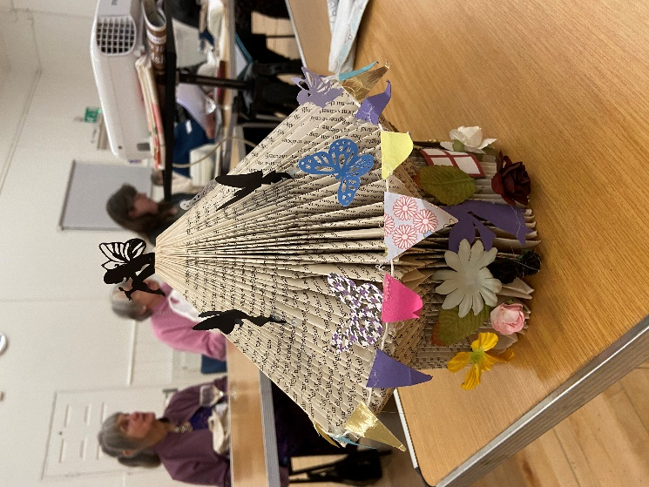

**RAFFLE** We are delighted to announce that last month’s raffle raised £60 for our funds.

Thank you all for supporting this.

**LUNCH CLUB**

All’s well that ends well. Our venue had to be rearranged at the last minute. Nevertheless 10 of us enjoyed a lovely meal at the Miller & Carter in Kidlington

**FUTURE EVENTS**

**WALKING GROUP**

**This will go ahead on Wednesday 20th March. The ground is still very saturated and so we shall be walking around Blenheim Palace grounds. Meet in the free car park in Woodstock at 10.30am. Lunch or refreshments afterwards at The Kings Arms, Woodstock.**

**WALTON MANOR KNIT AND NATTER**

The next knit and Natter meeting will be Tuesday 19th March

From 7 – 9pm at Catherine’s

92 Lonsdale Rd, OX2 7ER

Bring along your knitting/sewing etc and enjoy a coffee/tea and a good natter.

**OFWI UPCOMING EVENTS FROM OXFORDSHIRE INSPIRES**

**Talk about the Diamond Light Source,** Harwell.

Date 23rd May

Time 1.30 – 4pm

Where Benson Parish Hall

Cost £10 members £12 Non-members

**Visit to Packwood House NT and Merry** **Hill Shopping Centre**

Date Tues 16th April

£46.30 Non NT

Non Members £34 NT

Non Members £49.30 non NT

**From Garden to Plate**

Date Tues 11 June

Time 10.30am – 3.30pm

Venue Benson Village Hall

Cost £24 or £27 for non-members

This promises to be a super day for all gardeners and cooks. Talk and tips from Chris Day. In the afternoon we will be entertained by the well-known Paolo Arrigo.

**Pop up box Cards**

Date Thurs 25th April

Time 10 – 3pm

Venue OFWI Offices, Tackley

This is a workshop which is suitable for card makers with some experience.