

**WMWI**

**The National Federation of WI’s campaign to**

**improve women’s and family’s lives**

**Monthly Newsletter: JULY 2024: No 205**

[**www.waltonmanorwi.co.uk**](http://www.waltonmanorwi.co.uk)



**President:** Caroline Coleman -07850 830858

**Secretary:** Clare Wildish – 01865 556018 **Walton Manor WI Treasurer & Vice President:**  Liz Jennings –FA 07717 756338 Registered charity 1119651

**NEXT MEETING**

**WHEN Tuesday 9th July**

**WHERE St Margaret’s Institute**

**Polstead Rd**

**TIME 7.30pm for 8pm start**

Our speaker is Gary Collins – Turn End – award winning house and gardens.

Architect Gary Collins is the chair of Turn End Trust and a Senior Associate at Hassell Studios in London. Gary will explore the relationship of the house with its outside spaces.

**LAST MONTH’S MEETING**

**LUCY GLASSON – PITT RIVERS MUSEUM**

Pitt Rivers Museum is a museum displaying the archaeological and anthropological collections of the University of Oxford.

Augustus Henry Lane Fox was born in 1827. After a military career he retired. He unexpectedly inherited the estate and Pitt-Rivers name and became a very wealthy man. He got the “collecting bug” and the museum opened to visitors in 1887 and was fully open by 1892.

It has the title of displaying the most objects (over 300,00) on show in the world. Using slides Lucy showed us a variety of the many quirky objects that can be seen including a totem pole and magic objects. Asked about the shrunken heads, we were told that following controversy these have now been removed.

WI Walk

Six members set out on a circular walk around Stanton Harcourt. The tree lined lanes provided shade. We so enjoyed seeing all the wild flowers.

We also enjoyed seeing all the village decked out for their festival week. The theme was ancient Egypt which was displayed in very imaginative ways throughout the village. The flower festival in the church was amazing to see.

After the walk we visited an open garden courtesy of one of our members. Tea and cakes were much appreciated.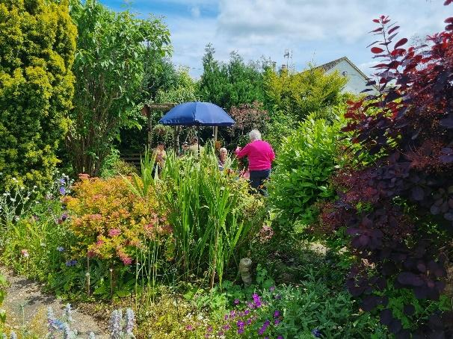

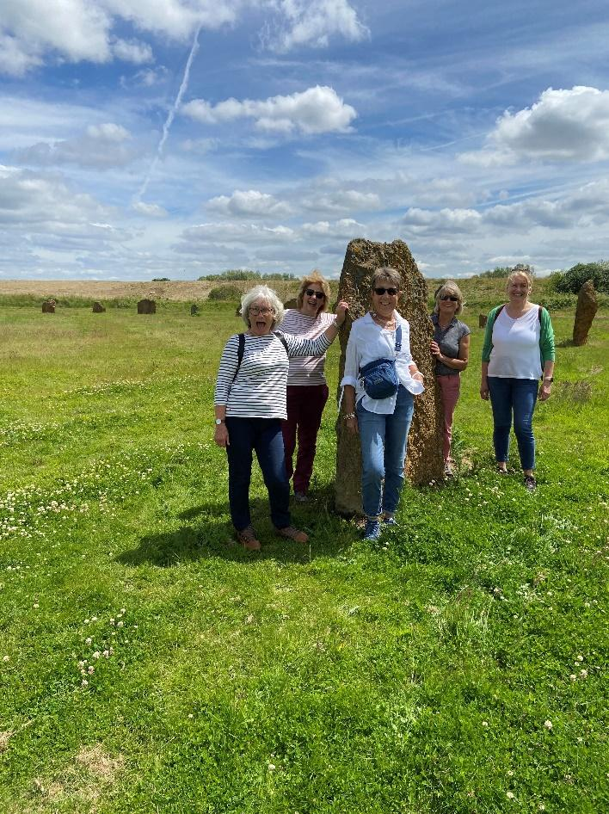

To finish off we went to see The Devil’s Quoits

Fully restored Stone Circle in Oxfordshire. The site is believed to be between 4000 and 5000 years old, and is a Scheduled Ancient Monument. The Quoits were restored between 2002 and 2008, with stones which had been knocked over or had fallen over being re-uprighted, and the surrounding earthworks re-built.

**FUTURE EVENTS**

**WALTON MANOR KNIT AND NATTER**

The next get together will be on

Tuesday 16th July

From 7 – 9pm

At Catherine’s, 92 Lonsdale Rd, OX2 7ER

Bring along you knitting/sewing etc and enjoy a coffee/tea and a good natter

**JULY WALK**

**This is scheduled for Wednesday 10th July. Further details to follow**

**VISIT TO SEZINCOTE HOUSE**

**This will be on Wednesday, 3rd July. The house tour will be at 2pm and the ticket cost is £15.00. Tea and cake is available afterwards in The Orangery. There are spaces still available if you wish to go. Please contact Anne (Cashmore) at anne.m.cashmore@gmail.com**

**VISIT TO THE COTSWOLD LAVENDER FIELDS, SNOWSHILL**

**WHEN JULY 16TH**

**TIME MEET THERE AT 2PM**

**COST £7.50**

**BRING YOUR OWN PICNIC**

**ARDLEY RECYCLING CENTRE**

**WHEN 17th September**

**TIME 2PM**

**OFWI UPCOMING EVENTS FROM OXFORDSHIRE INSPIRES**

**THE BARBARA GRAY MEMORIAL LECTURE**

**An Audience with Charlie Ross, Antiques expert, Presenter and Auctioneer**

**WHEN Tuesday 24th September**

**TIME 1pm – 4pm**

**VENUE Benson Parish Hall OX10 6LZ**

**COST £15 members only. Lunch will be served on arrival**

**SPEAKER SELECTION DAY**

**WHEN Thursday 12 September**

**TIME 10.30 – 4pm**

**VENUE TBC**

**COST £12 members only**

**WOMEN ON OXFORDSHIRE BLUE PLAQUES**

**WHEN Tuesday 26th November**

**TIME 11 – 1.30pm**

**COST £12 members £14 non-members which includes tea/coffee and cake**

**A DAY IN THE NEW FOREST**

**WHEN Wednesday 25th September**

**TIME All day event**

**COST £79 including a 2 course meal**

**ALL THE ABOVE EVENTS AND MORE INFORMATION. INCLUDING CLOSING DATES, CAN BE FOUND IN OXFORDSHIRE INSPIRES OR ON THE OFWI WEBSITE**

