

**WMWI**

**The National Federation of WI’s campaign to**

**to improve women’s and family’s lives**



**Monthly Newsletter: March 2025 - 212**

[**www.waltonmanorwi.co.uk**](http://www.waltonmanorwi.co.uk)

**President:** Caroline Coleman - 07850 830858

**Secretary:** Clare Wildish - 01865 556018 **Walton Manor WI Treasurer & Vice President:**  Liz Jennings 

**RegRegistered charity 1119651**



**NEXT MEETING**

**WHEN 11th March 2025**

**WHERE St Margaret’s Institute**

**Polstead Rd**

**TIME 7.30pm for 8pm start**

**ANNUAL GENERAL MEETING followed by the SPEAKER, our own member Sarah Ewart, who will talk about her work with the Nasio Trust, which is a registered charity based in the UK and Kenya**

**LAST MONTH’S MEETING**

Our demonstrator for the evening was Marea Brown. Having been given a demonstration on how to block print, 25 members knuckled down to create their own design. With the creative juices flowing, we all entered into the spirit of the evening. There were some great results and the event proved a big success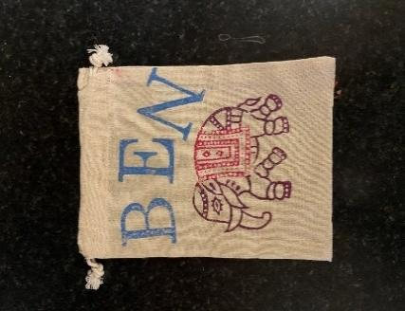



A few designs printed on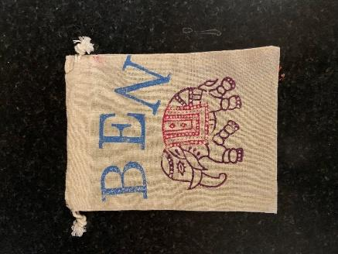

tea towels and small

drawstring bags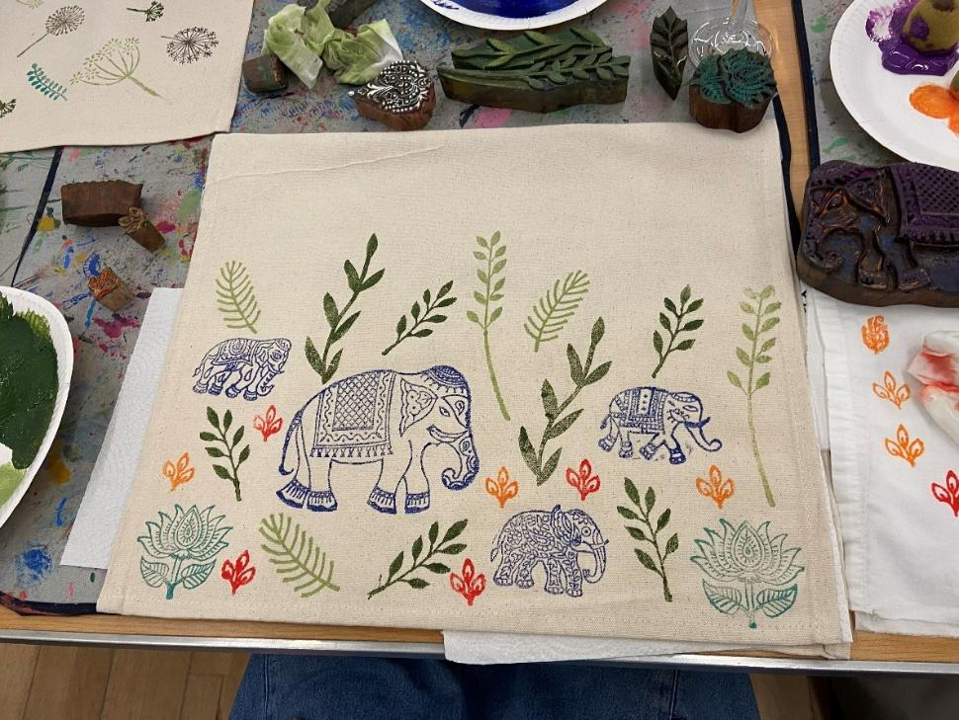



**WALTON MANOR’S VISIT TO ARDLEY ENERGY RECOVERY FACILITY**

Several members spent a couple of hours with an extremely knowledgeable lady at the plant. We were told of the procedure for converting rubbish into usable material that can be used by external companies to make into goods that can be sold on. The many stages of this were remarkable.

The journey starts with rubbish being tipped into this giant area, by huge lorries that have travelled from local rubbish collection points. See the picture below



This picture shows a life size dinosaur

Made with items of rubbish

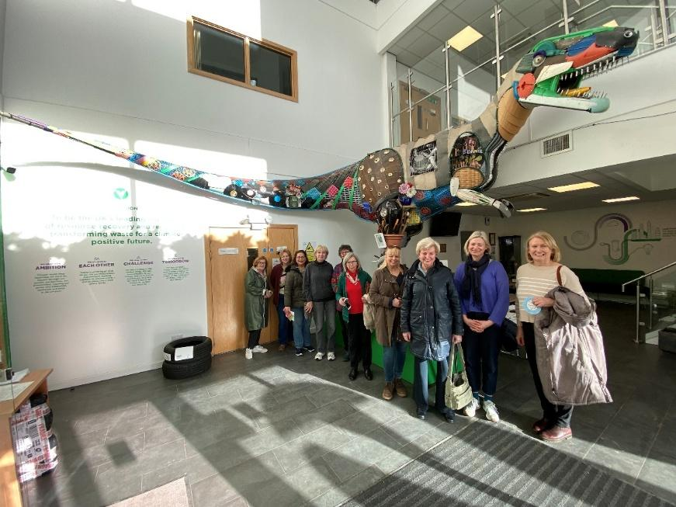

**FUTURE EVENTS**

**WALTON MANOR KNIT AND NATTER**

The next knit and Natter meeting will be on Tuesday 18th March

From 7 – 9pm at Catherine’s

92 Lonsdale Rd, OX2 7ER

Bring along your knitting/sewing etc and enjoy a coffee/tea and a good natter.

**WALKERS GROUP**

**The walking season restarts on Wednesday, 19th March. Meet at the George & Dragon Long Hanborough at 10.30**

**LADIES LUNCHES**

**Di (Williams) is very pleased to say that the next one will be on Thursday, 10th April at The Trout. 12.30 for 1pm.**

**FUTURE EVENTS PLANNED BY THE OXFORDSHIRE FEDERATION**

**A DAY OUT IN LONDON**

**Join is for an interesting, informative and stimulating day out in London. After we board our coach at our pick up point we travel first to The Royal Albert Hall, one of London’s most iconic venues. Here we will have a Guided Tour and will be able to partake of an included tea/coffee and cake. The RAH has always been synonymous with Royalty, but it is far more than that. This was the Suffragettes “Temple of Liberty” – the site of “Votes for Women” rallies.  Throughout its 150 year old history, it has paid host to numerous well known figures and performances from Einstein to Winston Church, from The Beatles to Adele and Ed Sheeran, from The BBC Proms to Cirque du Soleil. The tour lasts for approximately an hour,**

***The Royal Albert Hall and all tours are fully accessible for wheelchair users and customers with mobility issues*..**

**We then travel on to the British Museum, where we will be able to purchase lunch. Here we can immerse ourselves in two million years of human history, art and culture. Visit the galleries, artifacts and expand your knowledge in the numerous exhibitions.**

***As with the RAH, the British Museum wants to be open and accessible to all visitors to ensure that the widest number of people can enjoy the building, collection and exhibitions***

**Please note that tickets are non-refundable**

**This event is open to Members and Non-Members**

**Tea/coffee and cake are included in your visit to the Royal Albert Hall, lunch will be available to purchase at the British Museum.**

**All timings TBC**

**Pick-Up Points: Pear Tree Services and Didcot Marriott Hotel**

**Booking open from Monday 3 February to Friday 28 March , or until all tickets are sold**

**Malvern spring festival – Friday 9th May**

**Members £60**

**Non Members £64**

**Please note that tickets are non-refundable**

Based at the Three Counties Showground in Malvern, Worcestershire, and framed by the picturesque Malvern Hills, RHS Malvern Spring Festival is the perfect opportunity to prepare for the upcoming gardening season. One of the first major shows of the year, the festival opens the door into the summer season and its setting provides the perfect backdrop to a plethora of plants and gardens.

Enjoy a walk around the show gardens, gather inspiration from exhibitors and get hints and tips from a range of talks and demonstrations at this fantastic early season show. This wonderful Show has inspiring gardens, spectacular blooms and plenty of ideas to try at home. Plants for outdoors and indoors and an opportunity to learn from all the fantastic medal-winning gardens.

Join us and enjoy a magical day seeing some of the very best that the world of horticulture has to offer.

**HOUSES AND WINE IN THE GARDEN OF ENGLAND**

**WHEN SUNDAY 11TH MAY – THURSDAY 15TH MAY**

**COST NAT. TRUST MEMBER £858 NON NT MEMBER £893**

**Exciting 4 night/5 day holiday at the Tudor Park and Country Club near Maidstone. Bed, breakfast and dinner included. Visit to Rochester castle and cathedral, Hever Castle, Chartwell, Sissinghurst, Ightham Mote and Knole Park. Also wine tasting at Kingscote vineyard**

**ALL THE ABOVE EVENTS AND MORE INFORMATION. INCLUDING CLOSING DATES, CAN BE FOUND IN OXFORDSHIRE INSPIRES OR ON THE OFWI WEBSITE**