

**WMWI**

**The National Federation of WI’s campaign to**

**Improve women’s and family’s lives**

**Monthly Newsletter:JUNE 2024:No 204**

[**www.waltonmanorwi.co.uk**](http://www.waltonmanorwi.co.uk)

**President:** Caroline Coleman -07850 830858

**Secretary:** Clare Wildish – 01865 556018 **Walton Manor WI Treasurer & Vice President:**  Liz Jennings – 07717 756338 **Registered charity 1119651**

**NEXT MEETING – WMWI**

**WHEN Tuesday 11th June**

**WHERE St. Margaret’s Institute**

**Polstead Rd**

**TIME 7.30pm for 8pm start**

Our speaker is Lucy Glasson – The Wonderful World of the Pitt Rivers Museum. The much-loved Pitt Rivers Museum is unlike any other. Founded in 1834, it houses within an atmospheric building more than 500,000 objects, photographs and manuscripts from all over the world, and from all periods of human existence. Within these are exceptional objects of ritual significance, and objects made for tourist or trade

**LAST MONTH’S MEETING**

**MARY MCINTYRE TALKING ABOUT WOMEN ASTRONOMERS.**

Mary had been interested in the stars and planets since she was 3 years old and she explained to us that **t**hroughout history astronomy has been very male dominated. There have been many trailblazing women, such as Caroline Herschel, who have worked to change that, but in addition there were countless women working in astronomy before Caroline. Mary's talk tells their stories and highlighted many of the challenges women have faced historically and still face today.

Having set the scene, Mary gave us a whistle stop slide show of the most incredible women astronomers going back as far as the Babylonians 650BC!  She also told us that she really enjoys painting the planets and showed us some magnificent pictures which she had taken of the recent aurora borealis.

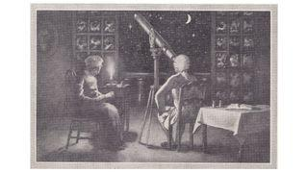

[Caroline Herschel](https://www.space.com/17439-caroline-herschel.html) is the first woman credited with discovering a comet and is also the first to receive honorary membership with Britain's prestigious Royal Society.

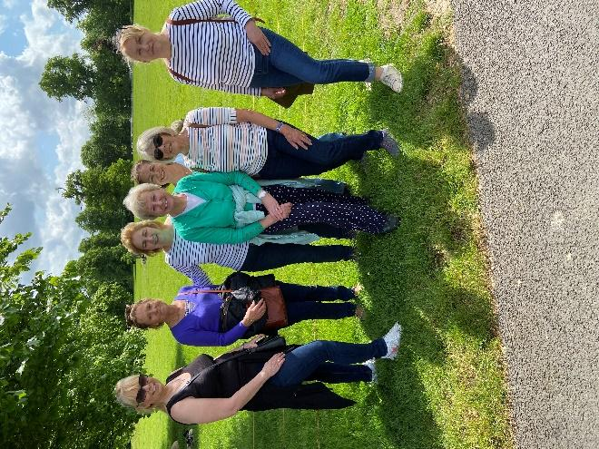

**THE INTREPID WALKERS**

On a beautiful spring morning 6 members walked through High Park, Blenheim. It was truly breathtaking to see huge gnarled trees, with lovely fresh, yellowy green leaves. Some of these trees were over 800 years old! A very convivial pub lunch was enjoyed afterwards at the Oxfordshire Yeoman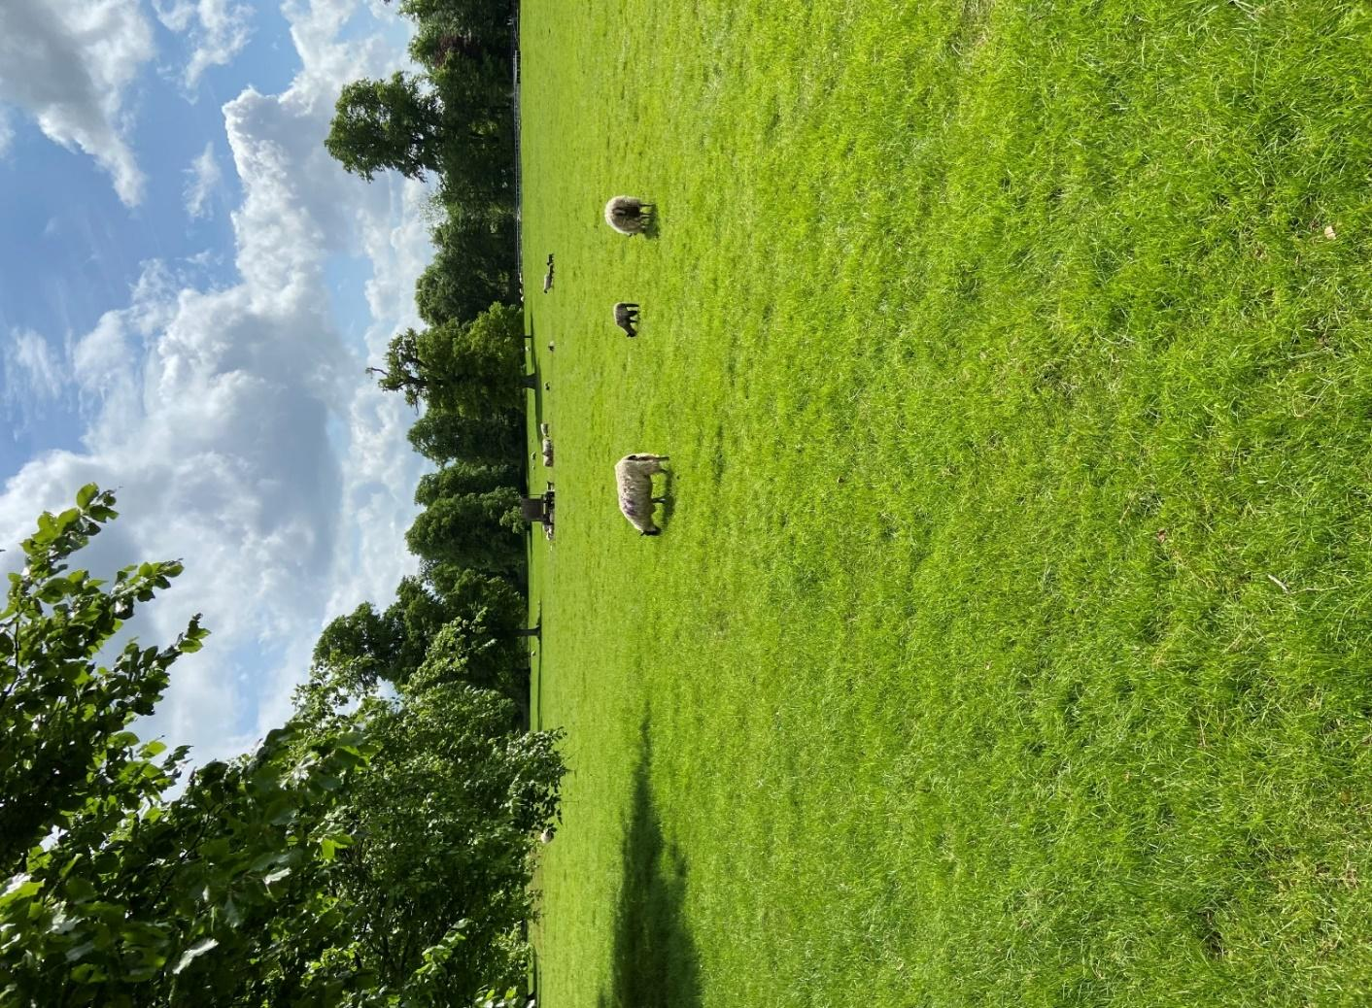

**FUTURE EVENTS**

WMWI LUNCH CLUB

The next WMWI lunch is at The Greyhound, Besselsleigh, nr Wootton, Abingdon. OX13 5PX on Thursday 27th June 12.30 for 1pm

For those who don't know the area well, it is on the right hand side of the A420. It is nowhere near Abingdon, and not far out of Cumnor.

**WALTON MANOR KNIT AND NATTER**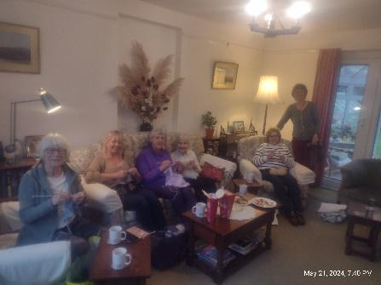

The next knit and natter meeting will be

Tuesday 18th June

From 7 – 9pm at Catherine’s

92 Lonsdale Rd, OX2 7ER

Bring along your knitting/sewing etc and enjoy a

coffee/tea and a good natter

**OFWI UPCOMING EVENTS FROM OXFORDSHIRE INSPIRES**

**The Barbara Gray Memorial Lecture**

An Audience with CHARLIE ROSS, Antiques expert, Presenter and Auctioneer

Date : Tues 24th September

Time : 1 – 4pm

Venue : The Parish Hall, Sunnyside, Benson OX10 6LZ

Cost : £15 members only. Lunch will be served on arrival

Opening date Monday 27th May

**WOMEN ON OXFORDSHIRE BLUE PLAQUES**

Professor Bob Evans FBA

Date : Tuesday 26th November

Time : 11am – 1.30pm

Venue : Beckley Village Hall, OX3 9 UZ

Cost :£12 members £14 Non-members

Opening date Monday 2nd September

**FROM GARDEN TO PLATE**

A representative from Buckingham Garden Centre will present “**The all-new A-Z of fool-proof gardening”**.

Date :Tuesday 11th June

Time : 10.30am – 3.30pm

Venue : The Parish Hall, Sunnyside, Benson OX10 6LZ

Cost : £24 members £27 non-Members. Tea and coffee on arrival, includes a two-course lunch, please bring a mug.

Opening date Tuesday 2nd April

**JAZZ UP YOUR JEWELLERY**

Date : Tuesday 3rd September

Time :Two separate half days session

10am – 12.30 **OR** 1.30 – 4pm

Venue : OFWI offices, Tackley OX5 3AL

Cost : £16 members only, including tools and materials.

Tea and coffee will be provided. Please bring a mug

**A DAY TRIP TO BLISTS HILL VICTORIAN TOWN and IRONBRIDGE**

Date : Thursday 11th July

Provisional pick up points, Peartree Services and Marriot Hotel, Didcot.

Cost £79 Members and £83 Non-Members

Opening date Monday 3rd June

**FULL DETAILS OF ALL THE ABOVE EVENTS CAN BE FOUND ON THE OFWI WEBSITE**