**WMWI**

**The National Federation of WI’s campaign to**

**improve women’s and family’s lives**

** Monthly Newsletter: NOVEMBER: 208**

[**www.waltonmanorwi.co.uk**](http://www.waltonmanorwi.co.uk)

**President:** Caroline Coleman -07850 830858 **Walton Manor WI**

**Secretary:** Clare Wildish – 01865 556018 **Registered charity 1119651**

**Treasurer and Vice President** : Liz Jennings – 07717 756338





**NEXT MEETING**

**WHEN Tuesday 12th November**

**WHERE St Margaret’s Institute**

**Polstead Rd**

**TIME 7.30pm for 8pm start**

Karen and Brett Wiles – Doing their bit: the WVS in WW2

The Women’s Voluntary Service (WVS) in World War II which is the largest female voluntary organisation ever

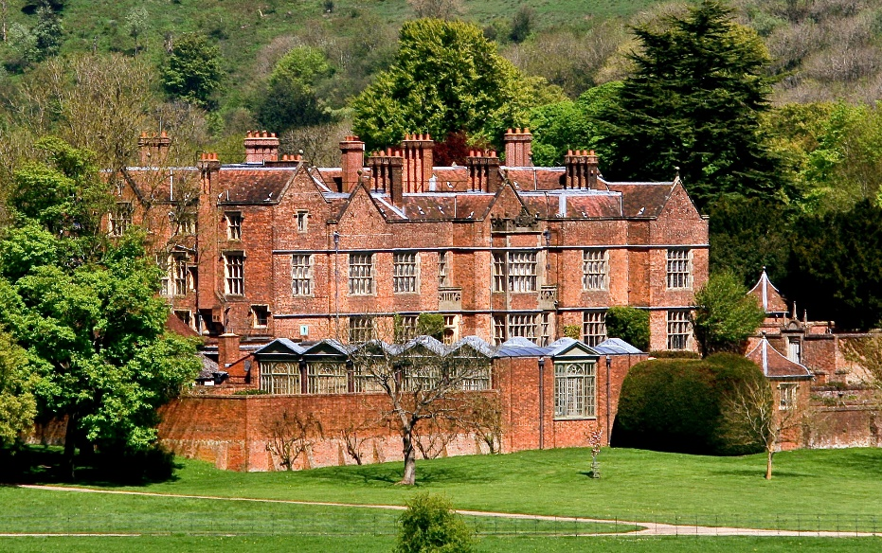**LAST MONTH’S MEETING** Alan Lavender MBE was for twenty four years the Head Chef at Chequers, the Prime Minister’s country residence, and also 10 Downing Street where he worked for four Prime Ministers starting with Margaret Thatcher and retiring when Gordon Brown left office in 2010.

He went to catering college and afterwards worked at some of the top London hotels. In 1973 he joined the RAF and worked in the catering department. In 1984 he was selected to work at Chequers.

During his time in post he cooked for most of the significant people of the era and many heads of state and royalty including the late queen.

Alan explained that the Chequers Trust owns the estate, but it is in complete control of whoever is prime minister at the time.

We were shown pictures of the various rooms and also the grounds, all of which were lavish

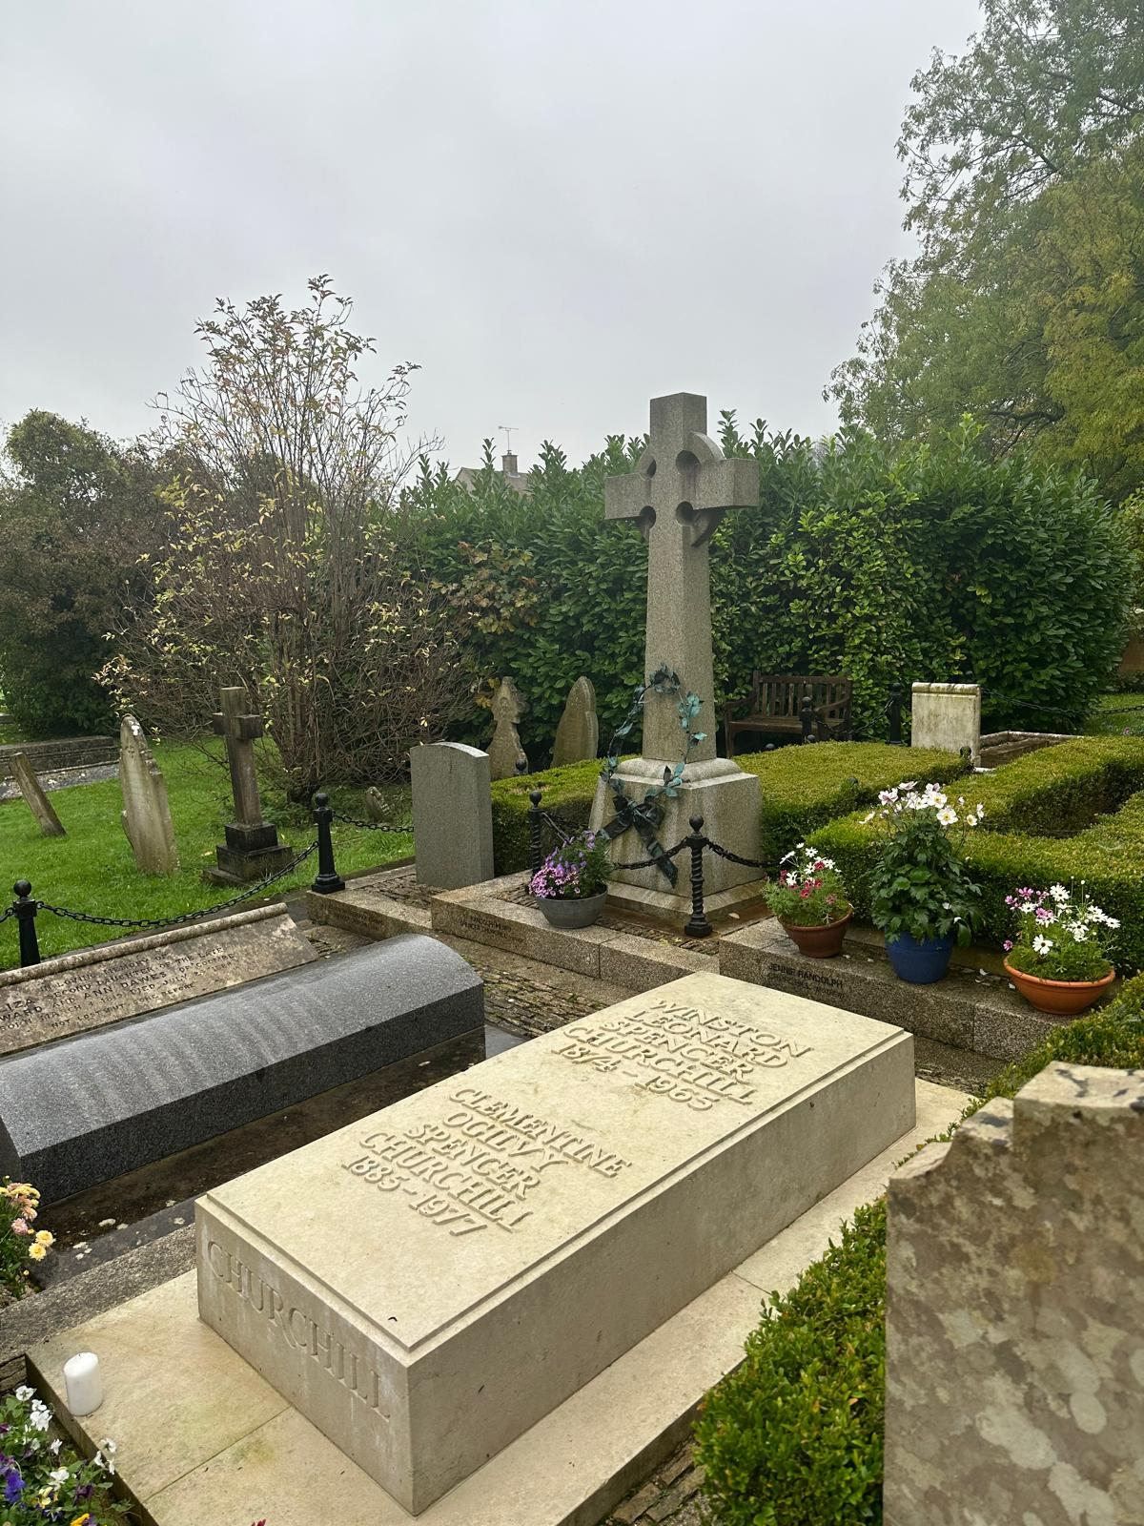He had a wealth of stories and anecdotes to tell, and gave us a glimpse of life at the table of the rich and famous

**October WI Walk**

**The walking group went on a lovely autumnal walk. It was a little bit drizzly but not too much rain.**

**The walk was through the Blenheim estate on the community path from Long Hanborough to Bladon . It was here that they popped over to see St Martin’s church and the Winston Churchill grave. After this followed a walk back to eat at the George and Dragon**

**Group Meeting**

Several of our members went to the autumn group meeting at Tackley Village Hall.

It was nice to see old WI members from other Institutes and also new members from the two recently added Institutes.

After the business we were enthralled to hear William French give us his career history. From the beginnings of joining the Royal Navy, where he did his basic training and also the Chef’s course, he moved to work for Sandy Woodward who was senior Royal Navy officer who commanded the Task Force of the Falklands War.

Before going to war he did a six week training on first aid and warfare and then went with “Sandy”on the HMS Broadsword which was the lead ship and first Batch 1 unit of the Type 22 frigates of the Royal Navy.

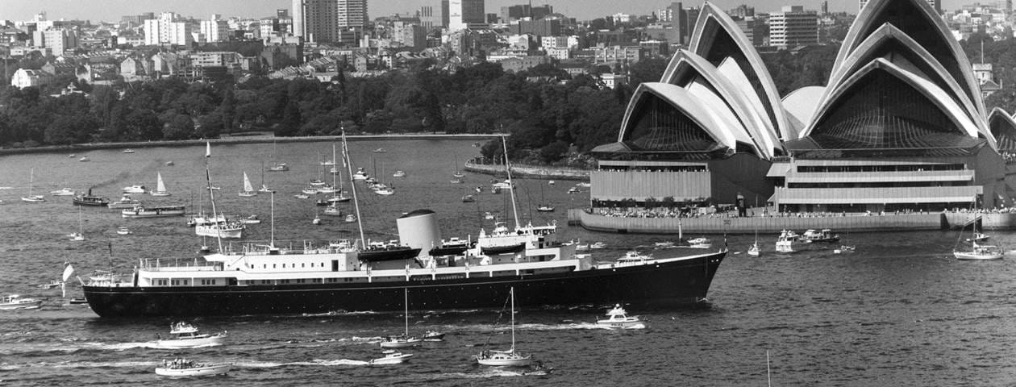After the war he was selected to be head butler to the Queen and other royalties on [the Royal Yacht Britannia where he spent the next 10½years. It was fascinating to hear about his experiences and to hear about all the wonderful countries he had been privileged to see. We saw photographs of the various rooms on the ship and were told that there were only single bedrooms on the ship. Following on from Britannia, William spent 2½ yrs working as butler to the queen at Buckingham Palace This was most enjoyable and following on from that he worked in Paris for Lord Rothermere. In recent times he has worked for many celebrities including Nicole Kidman and Tom Cruise](https://www.google.com/aclk?sa=l&ai=DChcSEwjYks6eyKSJAxXypFAGHQOUAMcYABABGgJkZw&co=1&ase=2&gclid=Cj0KCQjwveK4BhD4ARIsAKy6pMJVFpD3vFL00IM9GwiEkL6Ux7lHmPY9xkvOyDsDXjg7lkKc2ZW0kFAaAo9GEALw_wcB&sig=AOD64_1znLNwwiwL-ozzyt9_ZCKEuhgZuw&q&nis=4&adurl&ved=2ahUKEwiqrcaeyKSJAxWuT0EAHRpND8MQ0Qx6BAgFEAM)

**FUTURE EVENTS**

**Walton Manor Knit and Natter**

The next Knit and Natter meeting will be

on Tuesday 19th November

from 7 – 9 p.m. at Catherine’s

92 Lonsdale Road, OX2 7ER.

Bring along your knitting, sewing, darning etc

and enjoy a coffee/tea and a good natter.

**WMWI Lunch 13th November 2024**

The next lunch is planned for Wednesday 13th November at The Fox, Fox Lane, Boars Hill OX1 5DR.  As usual 12.30 for 1pm.  This is a change of venue from the one discussed at the last lunch. The Fox has fairly recently reopened and comes recommended by 1 of our members. Also, on phoning them, I was impressed by how friendly and helpful they were so it seems a good place to try for a new adventure. If you try googling them beware the old website may come up which says they are closed. I will of course be emailing you all again closer to the time.

Di Williams

**FUTURE EVENTS PLANNED BY THE OXFORDSHIRE FEDERATION**

**WOMEN ON OXFORDSHIRE BLUE PLAQUES**

**WHEN Tuesday 26th November**

**TIME 11 – 1.30pm**

**COST £12 members £14 non-members which includes tea/coffee and cake**

**FESTIVE CELEBRATIONS**

**WHEN: Thursday 12th December**

**TIME: 7.15pm – 9.45pm**

**Doors Open: 6.45pm**

**VENUE: St Peter & St Paul’s Church, Botley, Oxford OX2 9JY**

**COST: £13 members £15 non members**

**An evening of uplifting poetry, music and song. We will be joined by the Oxfordshire Inspires Ladies Choir and a number of supporting acts.**

**Refreshments and mince pies will be served on arrival**

**ALL THE ABOVE EVENTS AND MORE INFORMATION. INCLUDING CLOSING DATES, CAN BE FOUND IN OXFORDSHIRE INSPIRES OR ON THE OFWI WEBSITE**